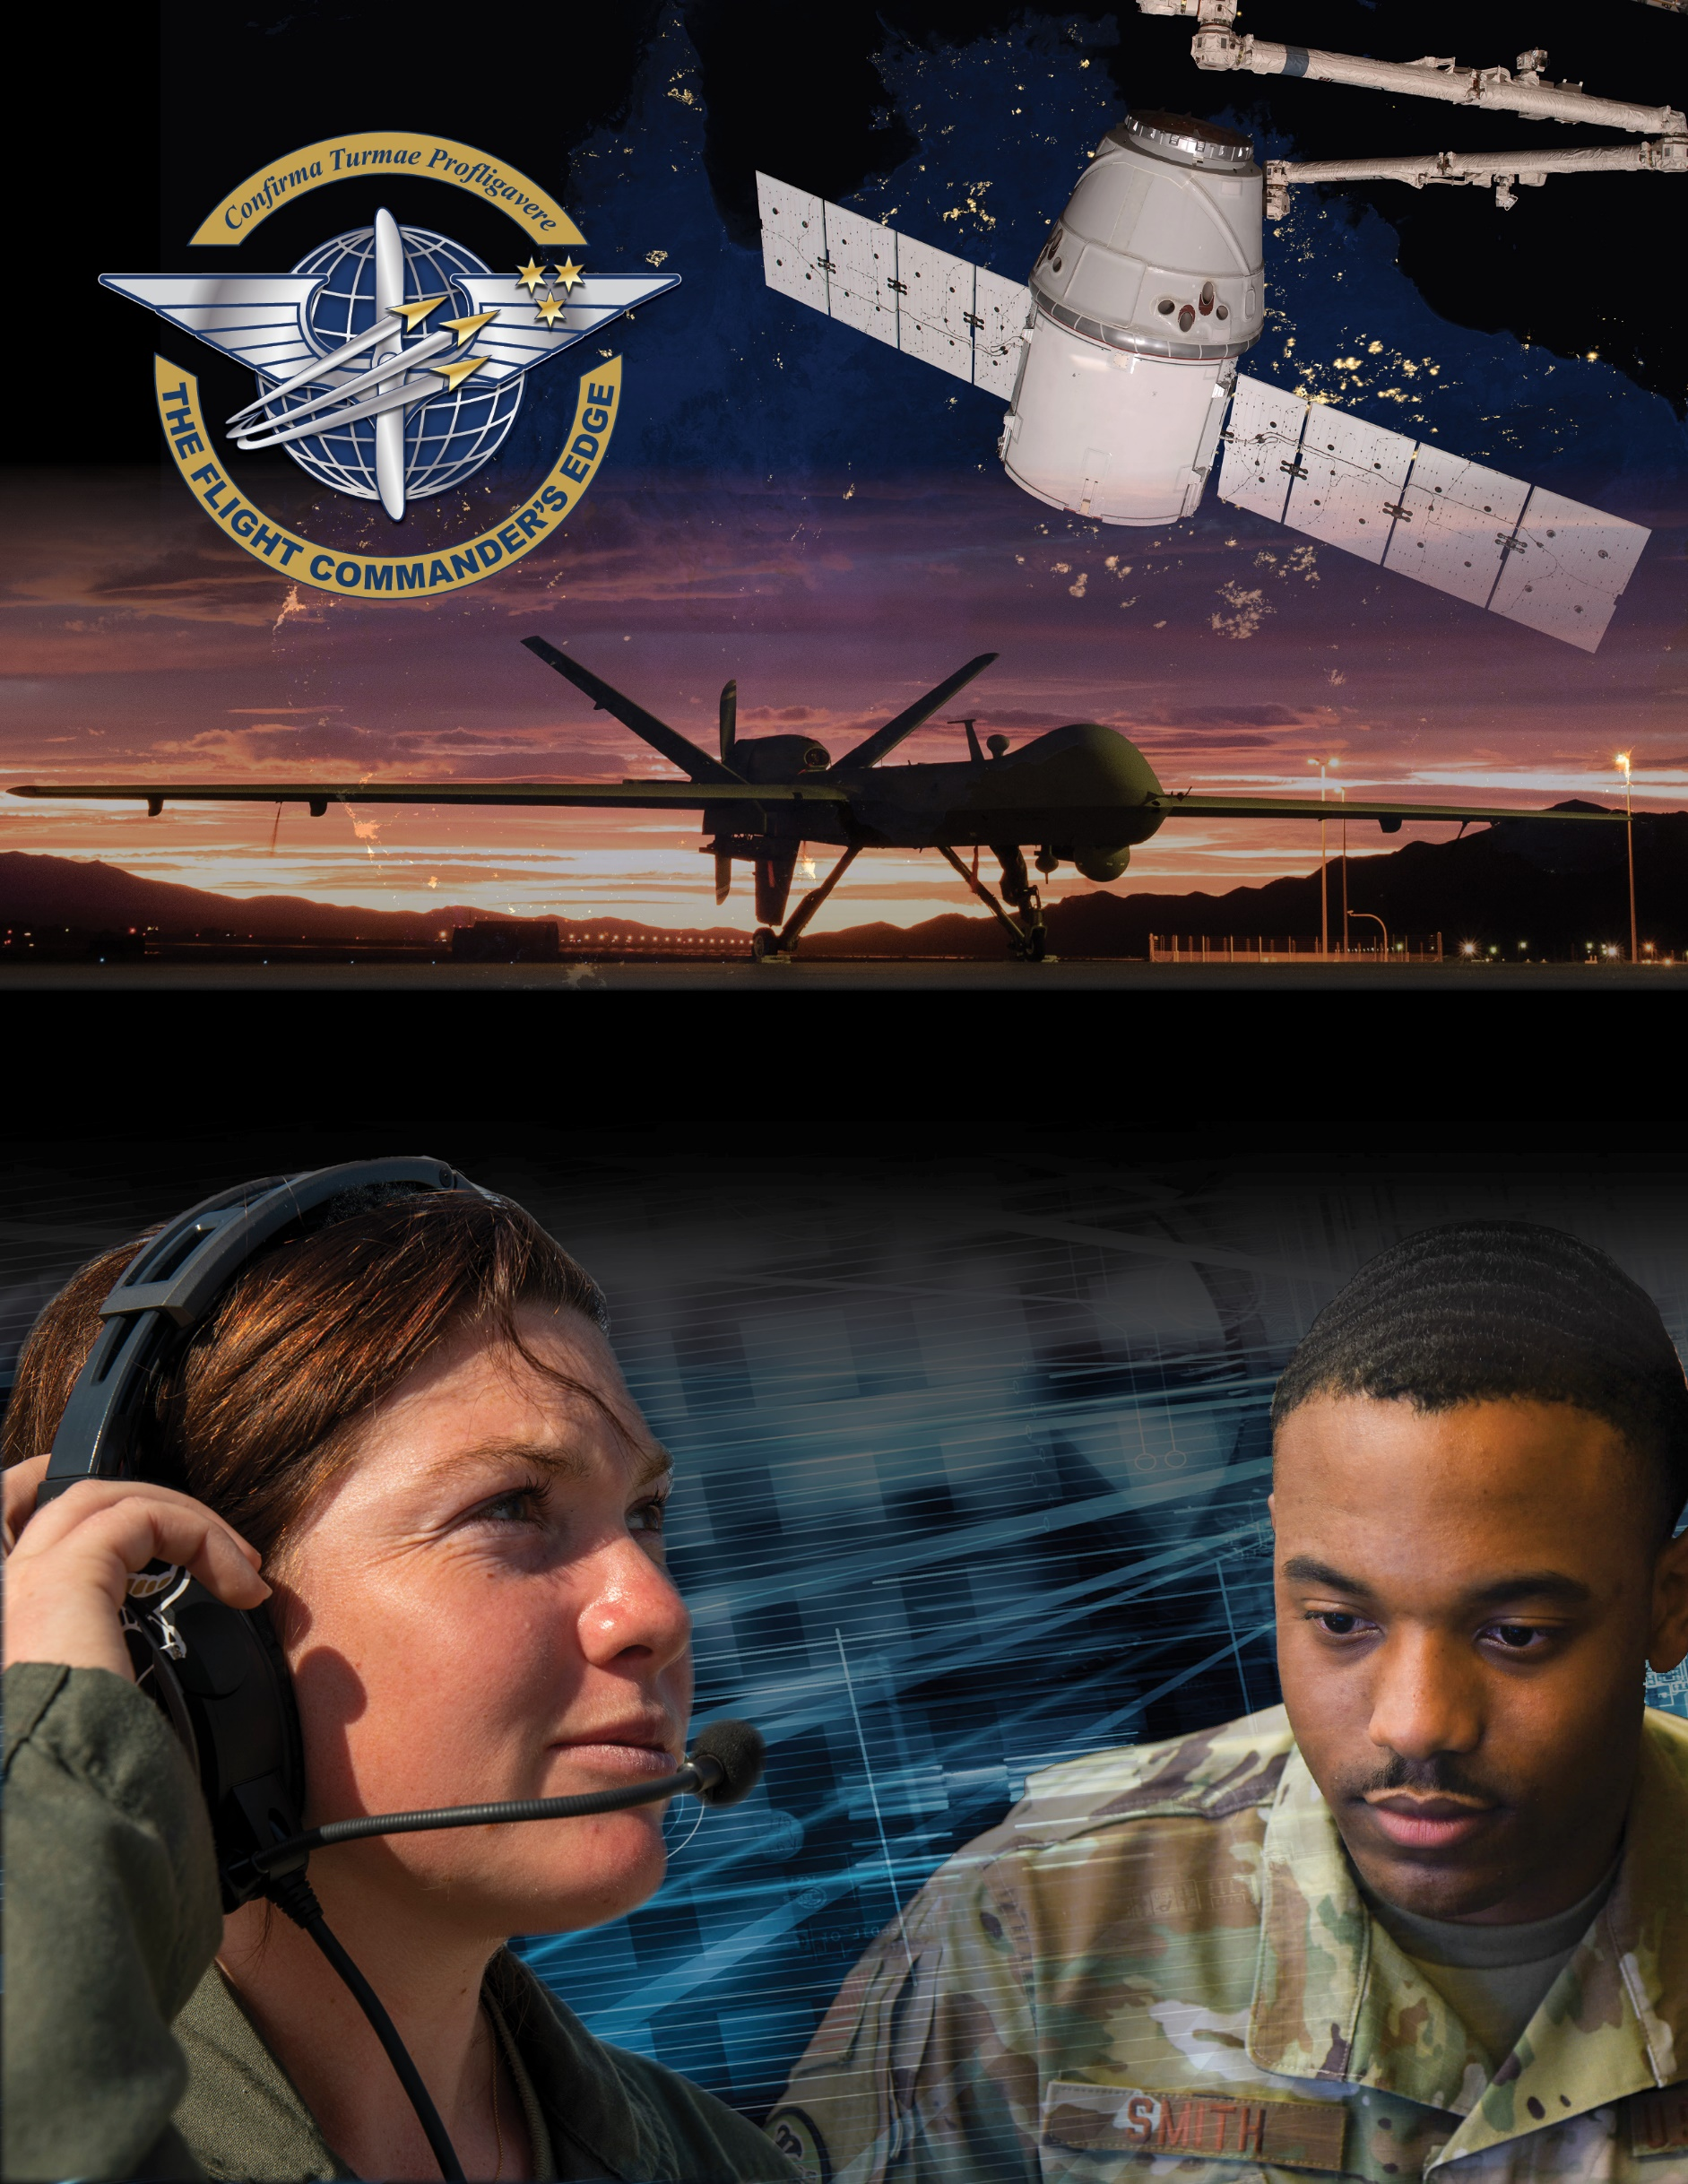

**Lesson Guide**

**Feedback**

***14 April 2025***

**Conducting and Documenting Feedback**

### Purpose

This lesson guide is designed to support the local development of Flight Commander Leadership Course materials. Selected facilitators should use this guide as they prepare presentation materials. For more information on how lessons are structured, or how to use them in the course, see the ***Course Director’s Handbook*** or ***Facilitator’s Guide***.

### Scope

Feedback carries a certain connotation in the military and can be used to set expectations, discuss performance, and chart a path ahead; however, poorly handled feedback can be demoralizing or ineffective. Whether formal or informal, feedback plays a crucial role in the development of every Airman and Guardian. Leaders should carefully think through feedback, seeking to provide it in a manner that can be received well and applied; otherwise, it will be of minimal or no use to the recipient.

As a Flight Commander, you will set the tone for how both formal and informal feedback is handled within your team. By giving behavior focused feedback that is timely, actionable, relevant, and respectful to the members of your team, and by holding others accountable to do the same, you will foster a culture in which feedback is sought out, integrated, and appreciated. However, ineffective, or non-existent feedback will foster a culture of apathy, resentment, and disregard towards the improvement of others.

### Recommended Objectives

By the end of this lesson, the participant should be able to:

1. Describe the requirements for and value of conducting and documenting constructive feedback using the Airman Comprehensive Assessment to frame desired performance.
2. Recognize the Airman Leadership Qualities characteristics which will help frame a successful feedback session.
3. Discuss techniques/approaches the participants use for conducting feedback sessions.

### Recommended POC / Presenter

* Anyone with extensive experience giving/documenting feedback (such as a graduated Sq/CC, Top 3, etc.)

### Recommended Length:

* 30 minutes (inclusive of questions)

### Recommended Approach

1. Present informational slides on Airman Leadership Qualities with Q & A broadly based on Executing the Mission, Leading People, Managing Resources, and Improving the Unit with more specifics from the participants based on their perceptions of the 24 Foundational Competencies found on the Airman Comprehensive Assessment form and on myFSS site.

### Lesson Connections

* **Developing Others**-giving others constructive, timely, and relevant feedback is a key component of development.
* **Professional Development**-during feedback one often discovers the training/educational needs and aspirations of others and can chart a path for them to achieve those goals.
* **Mentoring**-although not synonymous with feedback, these two activities often coincide.
* **OPRs/EPRs/Civilian Appraisals**-these formal processes drive the requirement for conducting and documenting feedback. Also, feedback of negative performance must be documented in order to be included in reports/appraisals.
* **Discipline, NJP, & UCMJ**-any disciplinary action must be documented and discussed during a feedback session. Proper feedback should preclude the need for disciplinary actions in many instances.

**Additional Discussion**

Visit DVIDs online site < dvidshub.net> and search for the video “Conducting feedbacks using the ALQs” - this short video can be used to jumpstart conversations with the participants.

**Point to Ponder**: When would it be appropriate to have a third-party present during a feedback session? (Consider when feedback may become contentious or must focus on a sensitive or disciplinary topic and how this action demonstrates “Leading People”)